Sole-Searching: How to find footwear to suit your needs AND your personality

Part 1 of 4: What to look for in a shoe

(Corresponding series installments are Part 2 of 4: Footwear Style Guide, Part 3 of 4: Understanding Rocker-Soles & Recommended Stable Rocker Shoes, Part 4 of 4: Tips & Tricks for optimizing Shoe- AFO pairing)

Did you know that shoes can be used to guess someone’s traits or characteristics? A 2012 study showed that 90 percent of a person’s personality is reflected in their choice of footwear.

For those of us needing ankle-foot-orthoses (AFOs) and restricted to wearing shoes that will accommodate our devices, what do our shoes say about our personalities?

Are our personalities now altered by our diagnoses... and is this now being reflected in our shoes?

Of course not! We are not defined by our injuries or conditions even though we may feel confined by them at times. This is why one of the most common complaints from AFO-wearers is not being able to wear the shoes of our choice; we want the same style options as everyone else.

The good news is that there are more stylish, orthotic-friendly shoes and boots available today than ever before. The key to finding your perfect shoe is to first understand how footwear is an integral piece in a 4-part puzzle:

Each of the above components are totally interdependent, with the first piece representing your Foot and its unique characteristics. These “unique characteristics” may include high arches, fallen arches, toe curl, bunions & calluses, sensory deprivation, metatarsal pain, ankle instability and foot drop—just to name a few!

In order to address these issues, and to restore proper alignment and gait, the next two pieces of the puzzle—the Orthotic Insert and the AFO—are critical. Your orthotist (or podiatrist, pedorthist, etc.)
will work with you on finding the best combination for your specific characteristics and needs.

When properly paired, Customized Inserts & AFOs
can offer these long-term benefits:
- Pain alleviation
- Fall-prevention
- Improved ankle stability
- Better proprioception, posture & balance
- Decreased rates of muscle atrophy
- Greater energy & confidence
- Improved overall quality of life

However, even the perfect Insert-AFO combination is incomplete without the fourth and final piece—the shoe. The characteristics and design of your shoe will determine what benefits you’re likely to receive from your orthotic devices. As such, the same care should be taken when selecting and customizing your footwear because only when this 4-part integrated system is fully optimized will you achieve the maximum benefit from your orthotics.

The following information is important to understand BEFORE selecting shoes based solely upon your fashion preferences.

Orthotic-friendly shoes can reflect your individual flair and panache if you know what to look for and where. While you may not be able to wear stiletto heels or flip flops with your AFO, there are countless fashionable styles that are indeed AFO-friendly, with many companies now offering larger selections of “adaptive and attractive” footwear. Below are key features to look for before choosing your favorite style:
Look for shoes with:
- Removeable Insole – allows for proper positioning of AFO and use of custom inserts
- Roomy Toe-box – allows room for AFO and toe crest pads or spacers for those with toe curl
- Firm heel, adequate heel-height – allows for optimal function of AFO, increases stability
- Extra-depth – allows room for AFO and arch supports or metatarsal pads to alleviate pain
- Fully extended zippers – especially in boots, these allow for easy insertion/removal of AFO
- Laces or buckles – provide more secure closures than Velcro to keep AFO in place
- Stable, Rocker-bottoms* – footwear with slightly rounded, elevated heel and a mostly flat sole that curves up near the toe. Stable rocker soles facilitate forward motion and proper gait mechanics*

*UNDERSTANDING THE IMPORTANCE OF STABLE “ROCKER-BOTTOM” SHOES

In brief, there are basically 2 categories of rocker-bottom shoes: stable and unstable.

Unstable rocker soles are not only controversial for all wearers (as noted in above recommended reading) but they are generally NOT RECOMMENDED for anyone wearing an AFO. Rather, most AFO manufacturers & orthotists recommend stable, rocker-bottom shoes for people wearing any type of foot and ankle bracing.

A stable, rocker-bottom shoe is described as one that:
- Is stabilizing in stance phase (meaning, while standing in place, the wearer feels fully balanced and supported by the shoe)
- has a mostly-flat sole that is supportive & thicker than in shoes categorized as “flats”
- has a heel that is slightly more elevated & tapers down towards the midfoot
- has a heel that is mostly rounded, mimicking the curved anatomical shape of the ankle
- adds a slight upwards curve at the heel & at the toe which “assists with the propulsive phase of gait, making walking more natural and less painful to the affected joints.”¹ (add wiki footnote for credit)

Below is a comparison of unstable and stable rocker-soled shoes to better illustrate the distinction between the two:
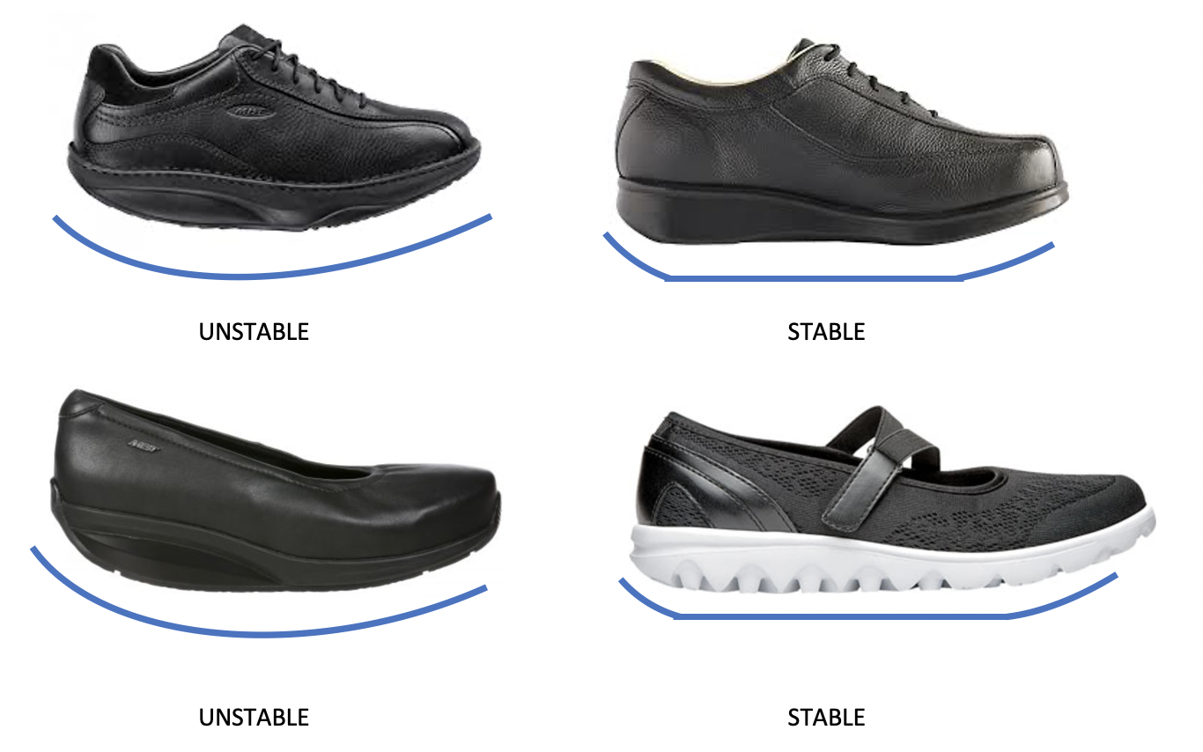
The following image depicts the rounded-heel design as well as the slight upwards curve at back of heel and at the toe of various stable, rocker-bottom shoes. (Note: photo represents Dr. Comfort® shoes and was sourced from https://www.drcomfort.com/about/our-shoes )

More considerations when searching for comfortable, stylish AND functional footwear:
Try going up a half or full size in your footwear to accommodate your orthotics. Many physical therapists and athletic coaches say that going up a full size in footwear should not significantly affect fit or function; there are lacing techniques and other “solves” for this issue. They also advise that going up 1 size can offer your feet extra room “to breathe” more comfortably due to foot swelling from weather conditions or increased activity levels. However, if this option is uncomfortable for you some vendors will allow you to purchase two different sizes in a shoe pairing so be sure to ask each vendor during your shopping efforts (read further for more on this).
Be sure to try as many styles and brands of footwear as possible; your “footwear puzzle” is unique to you alone and so it may take many tries to find a pair that you love. If in-person shopping is not a good option for you then look for online retailers that offer free shipping and/or returns (read further for more on this).
Be prepared to pay more for shoes with orthotic-friendly features. This may be hard to accept at first but the reality is that in most cases you do “get what you pay for” so, when your comfort, safety and overall quality of life are at stake, you should take care to select shoes that will not only fit your needs and your lifestyle but that will also last you for a very long time. If this means spending a bit more it will most likely be worth it in terms of fit and function for you in the long run when compared to less functional, poorly-made cheaper footwear.
Select as few pairs of footwear as possible that will still cover all the occasions in your life (i.e; exercise/sporty, work casual, formal events, fun/dressy daily-wear) in order to save yourself time and money. Consider selecting footwear that will work for multiple life-occasions, such as a pair of boots that may work with your formal apparel as well as your casual daily wear, or stylish athletic shoes that may also be considered as appropriate for your “business casual” attire. Once you’ve found a pair you really love, inquire with that vendor or maker about other styles that particular brand has available that may fit you just as well. For instance, if you have a Mary Jane-style shoe you love from a brand, ask them whether they make Boots with similar features because chances are they are likely to offer multiple options that complete your unique “footwear puzzle”.
Know what options you have to “customize” your footwear. Just as when buying off-the-rack clothing you can make alterations, the same goes for your shoes and boots. You have multiple options for converting and repairing the elements of your shoe or boot by utilizing local (or online) shoe-repair stores, pedorthist offices, select podiatry practices and even custom-shoe makers.

Finally, familiarize yourself with your AFO/Orthotics manufacturers’ recommendations regarding footwear. It is important that you understand these guidelines to ensure that the shoes you select adhere to these or you may risk causing harm to yourself or to your orthotic devices.

Today it’s easy to find high-end retailers offering selections of adaptive shoes and boots, but the odds of finding your perfect pair are made better by opening your search to include:
- Online retailers like Zappos and ShoeStores.Com who offer free return shipping if you are unsure if a shoe will work with your AFO
- Adaptive Footwear sellers who specialize in corrective footwear like Orthotic Shop, Dr. Comfort®, Flow Feet and The Healthy Feet Store
- Mainstream retailers like Nordstrom, Birkenstock®, L.L. Bean and many more who offer
odd-sized pairing for little or no extra cost and easy-returns policies (recently online retailer Zappos began offering free odd-sized pairing as well)
- Certified Pedorthist facilities, or “footwear pharmacies”, who offer custom-crafting services along with specialty shoe selections
In addition to searching online and retail outlets, it can be helpful to look for brands that are known for their stylish, adaptive lines of shoes and boots, such as: Aetrex®, BeautiFeel®, Drew®, Ecco®, TheNorthFace®, Propet®, Rockport®, Waldlaufer®, Wolky®, just to name a few.
The bottom line is that needing to wear an AFO should not limit how we present ourselves to the world: Our choice of shoe should speak more about our personalities than our disabilities.

